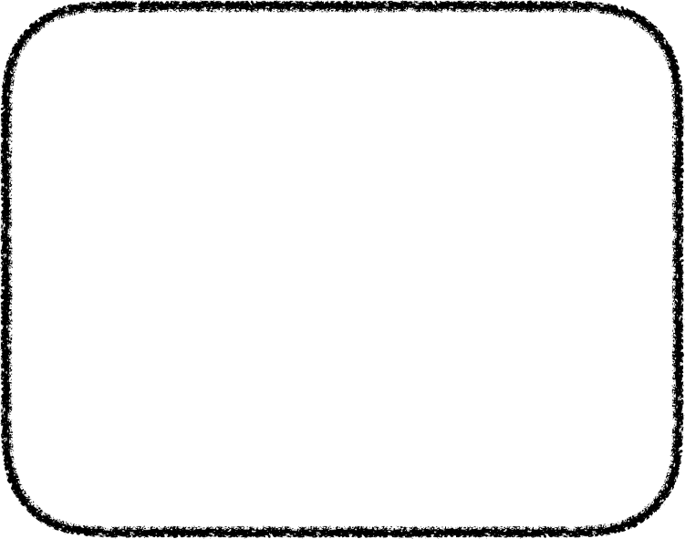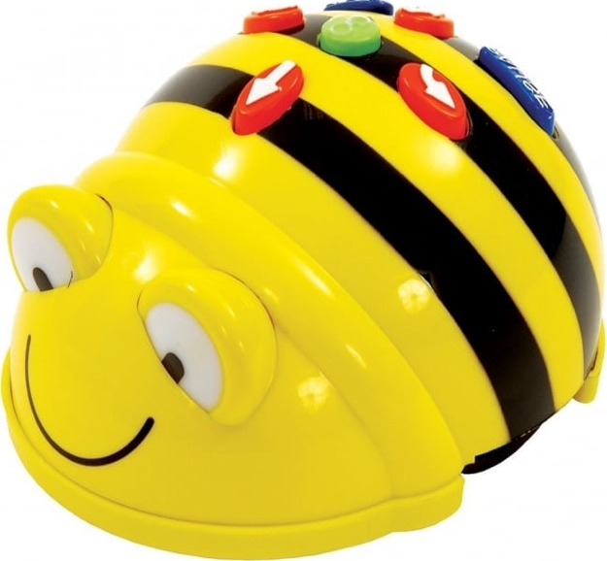

Recycling Center

Recycling in Our Community

Beebot will be collecting recyclable materials around town. Follow the directions below to help him collect them all to take to the Recycling Center.

* Create a container that Beebot will use to collect the materials. It must be attached to the back of Beebot.
* Build a Recycling Center with provided blocks and place it in your Community.
* Choose 3 location cards. Use a spinner to get the number of recyclables at each location. Place on the map.
* Use the arrow buttons to program or tell Beebot where to make stops in the community to collect recyclable materials. The last stop will be the Recycling Center.
* Take pictures or record a video in **Seesaw** to tell how your group completed your task.
* Upload to Seesaw.

Scan to hear directions

